Clondalkin Parish Census 16/17 November 2013

Introduction
A Census was carried out at all Masses in Clondalkin Parish on the weekend of 16/17 November 2013. This Parish Census counted 1,556 people at Mass. Table1 shows the results at each Mass, along with the numbers counted in October as part of the Archdiocese headcount.

Table 1: Attendance at Mass in the November Parish Census
Location | Mass | November Parish Census | October head count
Clonburris | 6.30pm | 49 | 79
 | 11am | 82 | 87
Knockmitten | 6.30pm | 107 | 115
 | 10am | 93 | 81
 | 12pm | 193 | 142
Village | 7.30pm | 204 | 213
 | 9am | 91 | 87
 | 10.30am | 240 | 274
 | 12pm | 326 | 361
 | 5.30pm | 171 | 204
Total |  | 1,556 | 1,643

Age Groups
A Census of Population was carried out in Ireland in 2011 which counted the population of Clondalkin Parish at 14,508 people. The Catholic population of the parish was counted at 11,730 people. Table 2 below shows this information by age group, and also includes the 1,554 people in the Parish Census who supplied their age. The last column calculates the % attendance at Mass by the Catholic population of Clondalkin.

Table 2: Age groups in the Parish Census compared to COP 2011
Age group | Census of Population 2011 |  | % Catholic | Parish Census | % Mass attendance of Catholic population in Clondalkin
 | Total | Catholics
0-4 | 1,134 | 842 | 74.3 | 25 | 3.0
5-9 | 871 | 685 | 78.6 | 70 | 10.2
10-14 | 788 | 663 | 84.1 | 72 | 10.9
15-24 | 1,896 | 1,537 | 81.1 | 67 | 4.4
25-34 | 3,028 | 2,301 | 76.0 | 93 | 4.0
35-44 | 2,059 | 1,571 | 76.3 | 128 | 8.1
45-54 | 1,939 | 1,647 | 84.9 | 209 | 12.7
55-64 | 1,399 | 1,203 | 86.0 | 309 | 25.7
65-74 | 873 | 799 | 91.5 | 339 | 42.4
75-84 | 391 | 358 | 91.6 | 191 | 53.4
85+ | 130 | 124 | 95.4 | 51 | 41.1
Total | 14,508 | 11,730 | 80.9 | 1,554 | 13.2

Table 2 shows that attendance at Mass during the Parish Census represented 13.2% of the Catholic population in Clondalkin Parish. Mass attendance is highest among the older age groups, with the highest rate of 53.4% for those aged 75-84 years while just 4% of Clondalkin Catholics aged 25-34 attended Mass in the Parish on the weekend of the Parish Census. This information is shown clearly in the graph below.
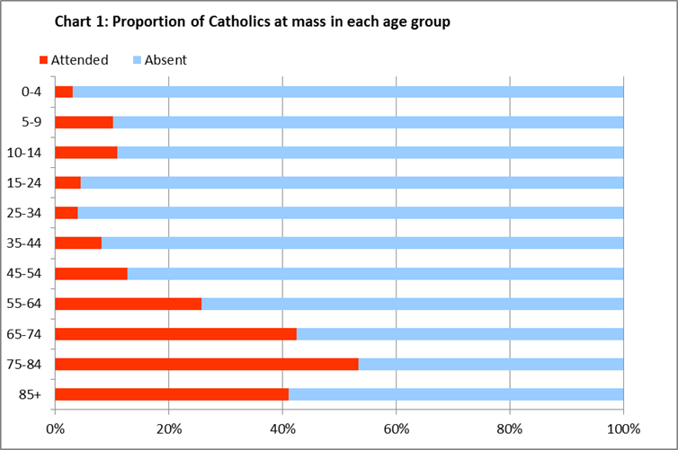

Table 3 below shows the numbers at each Mass in the Village, Clonburris and Knockmitten churches by age group.

Table 3: Attendance at each Mass in the Parish Census by age group
Age | Village |  |  |  |  | Clonburris |  | Knockmitten |  |  | Total
Group | 7.30pm | 9am | 10.30am | 12pm | 5.30pm | 6.30pm | 11am | 6.30pm | 10am | 12pm | number
0-14 | 18 | 8 | 10 | 46 | 19 | 6 | 4 | 2 | 10 | 44 | 167
15-24 | 5 | 1 | 5 | 21 | 7 | 1 | 3 | 7 | 1 | 16 | 67
25-44 | 23 | 11 | 29 | 51 | 43 | 7 | 6 | 12 | 10 | 29 | 221
45-64 | 81 | 27 | 71 | 118 | 61 | 14 | 20 | 39 | 26 | 61 | 518
65+ | 76 | 44 | 125 | 89 | 41 | 21 | 49 | 47 | 46 | 43 | 581
Total | 203 | 91 | 240 | 325 | 171 | 49 | 82 | 107 | 93 | 193 | 1,554

- Nearly a quarter (44 people or 23%) of those at the 12pm Mass in Knockmitten were aged 0-14 compared with 11% of the overall total in the parish.
- A quarter (43 people) of those at the 5.30 Mass in the village were aged 25-44 (compared to 14% of the overall Parish total).
Chart 2 below shows the age groups at each Mass in the Parish.

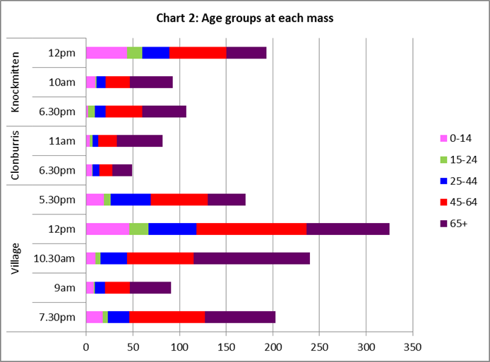

Nationality
Table 4 below show the various nationalities at each Mass in the Parish Census.
 | Table 4: Nationality by Mass
 | Village |  |  |  |  | Clonburris |  | Knockmitten |  |  | Total
 | 7.30pm | 9am | 10.30am | 12pm | 5.30pm | 6.30pm | 11am | 6.30pm | 10am | 12pm
Irish | 193 | 86 | 216 | 259 | 137 | 46 | 81 | 103 | 89 | 177 | 1,387
Polish | 1 | 4 | 14 | 35 | 21 | 0 | 0 | 0 | 3 | 8 | 86
Other EU | 5 | 0 | 6 | 14 | 9 | 0 | 0 | 3 | 1 | 7 | 45
Outside EU | 5 | 1 | 4 | 18 | 4 | 3 | 1 | 1 | 0 | 1 | 38
Total | 204 | 91 | 240 | 326 | 171 | 49 | 82 | 107 | 93 | 193 | 1,556
Other Nationality | 11 | 5 | 24 | 67 | 34 | 3 | 1 | 4 | 4 | 16 | 169

This table shows several interesting points:
- Just over one in ten (169 people) of those who attended Mass during the Parish Census were of another nationality. The Census of Population 2011 recorded that 23% of people living in Clondalkin Parish were from another nationality.
- The largest other nationality grouping were people from Poland – 86 people or nearly 6% of those who went to Mass.
- Some Masses were very popular with people from Poland, in particular the Village 12pm and 5.30pm Masses. These Masses were also popular with people from other European Union (EU) countries and countries outside the EU.
- Approximately one in five (or 20%) of the people at the Village 12pm and 5.30pm Masses were of another nationality and just over one in ten people at the Village 12pm Mass were from Poland.

Chart 3 below shows the various nationalities at each Mass.

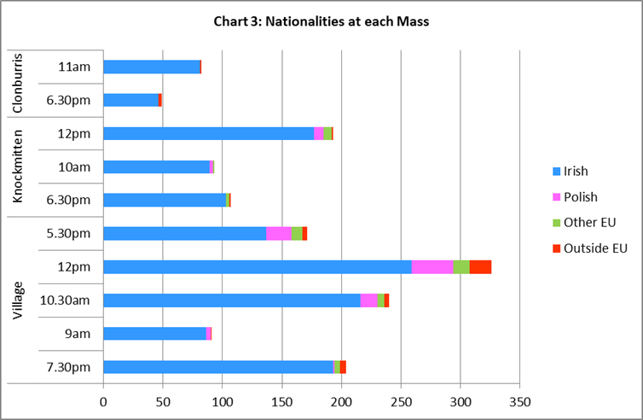

Some other interesting findings from the November Parish Census are:
- The average age of people at Mass was 53 years.
- The average age of Irish people at Mass was 55 years, while Polish people had an average age of 30 years.
- 29 of the 91 people at the 9am Village Mass (which is celebrated in Irish) took an Irish version of the Census form.
- Of the 393 people who attended Mass in Knockmitten, 139 were from the Village part of the Parish.

The Priests of the Parish and the Parish Pastoral Council would like to thank everyone who attended Mass on the weekend of the parish Census for their generous co-operation with the survey.

